RAMP: Radio Automation Management Program
A simple program to for radio automation. When you need more than WinAmp, but don't want a full-blown professional package.
RAMP is a program for the WinTel environment that automates standard radio station broadcast operations
- Right Click on the RAMPv2BetaExecutable - unzipping them
- Click RampV2.exe. – to run the program

RAMP Tutorial: Basic Overview
The RAMP interface is divided into 4 sections. The first is
Broadcast:

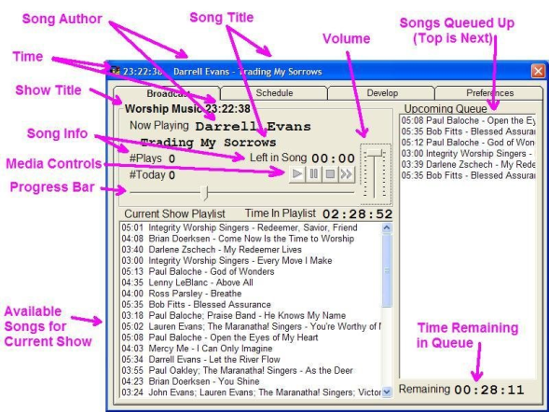
Schedule:
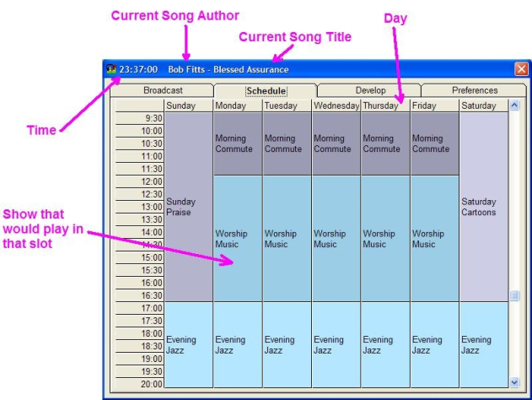

Develop:
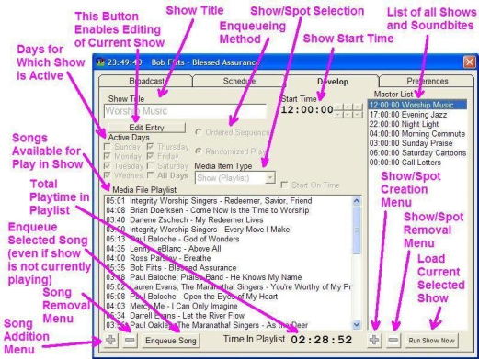

Preferences:
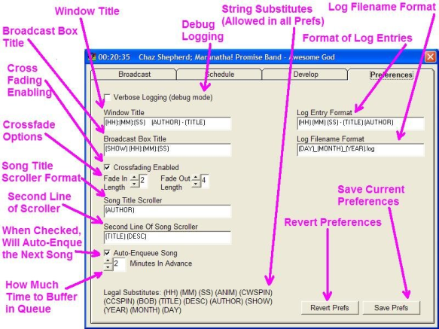

RAMP Tutorial: Creating a Show

To create a show, first we click the Add Show sub-menu option.
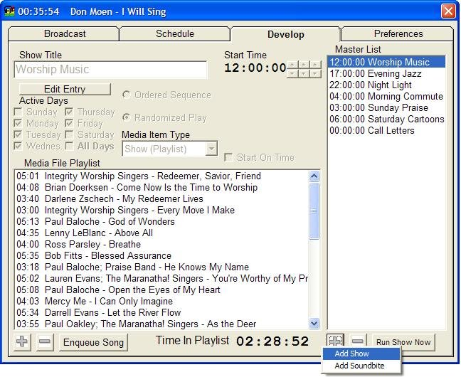
We then fill in the show title, whether or not it's an ordered or randomized playlist, active days, and the start time of the show. If you click "Start on Time", when the show's starting time rolls around it will stop whatever song is currently playing from the last show and enqueue the first song from the currently upcoming show.
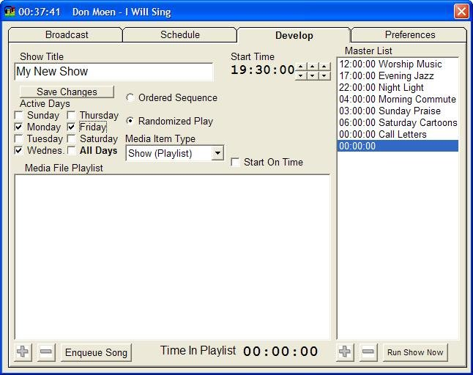
Next, we click on the "Save Changes" and click on "Add File" in the playlist submenu to begin adding media files to the show playlist.
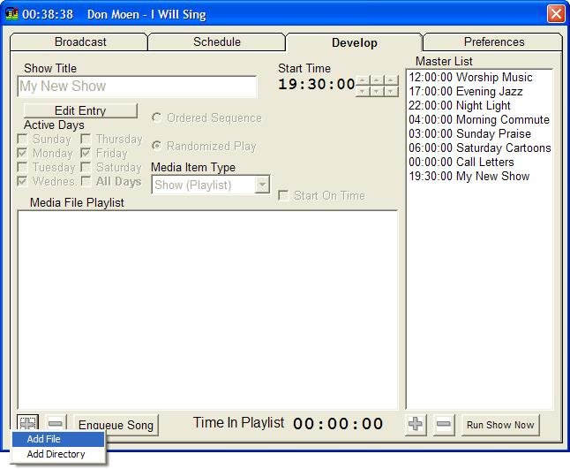
We then locate the songs that we want to add and use multi-select (shift-select and ctrl-select). Once we have them selected, click on "Open".
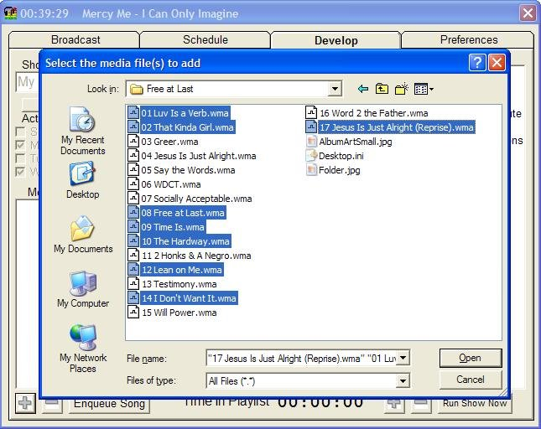
Voila! We have a fully-customized show with playlist and scheduled times.
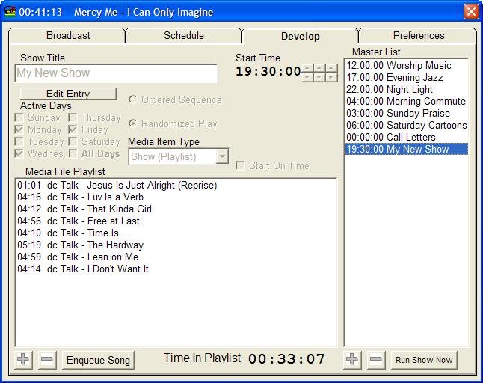

RAMP Tutorial: Creating a Soundbite

To create a soundbite, first we click the Add Soundbite sub-menu option.
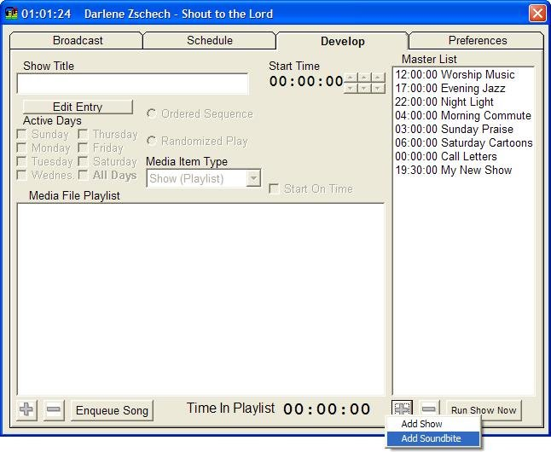
We then fill in the spot title, whether or not it's an ordered or randomized playlist, active days, and the time of day that the soundbite will start playing. There are two new options available for spots -- frequency and stop after time. Frequency is how often a song from the spot playlist will be enqueued in the broadcast queue. Stop after is after which time the soundbite will no longer play during the day. For the example in this screenshot, we have set a random funny to play every 25 minutes between the hours of 1:00 PM and 8:00 PM.
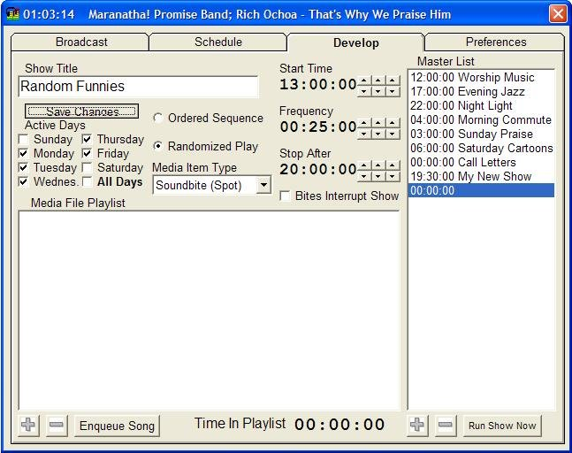

Next, we click on the "Save Changes" and click on "Add File" in the playlist submenu to begin adding media files to the show playlist. Note that no matter how long this playlist is, each spot trigger will only enqueue one media file from this playlist (I.E. it won't play the whole playlist each time, just one selection from the playlist).
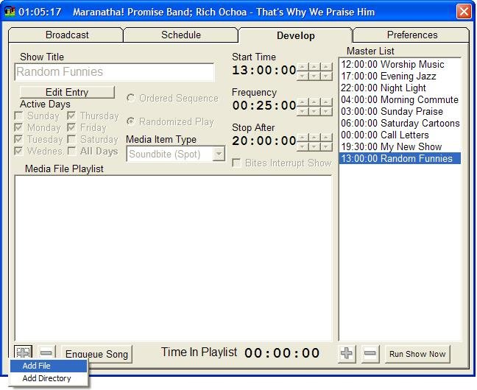

Continue to add songs as in the show example until you've created the playlist that you want.
